Date: October 17, 2024
To: Oregon Chapter, Membership and Bylaws Committee Co-chairs Renault and Hipes
From: Steve Mawdsley, President
Re: Proposed Amendment to Bylaws

(Per existing Chapter Bylaws)
- An amending proposal shall be submitted by the maker in written or electronic form to the Secretary, with a copy to the Chair of the Membership/Bylaws Committee, and its format shall:
  - Indicate the INTENT of the proposal;
1. Clarify the term of an Interim Executive Councilperson (Article III, Section 4, Paragraph B, Subsection 1).
2. Clarify the effective date of the Executive Councilperson (Article IV, Section 2, Paragraph F).
3. Add the Finance committee to the Standing Committees (Article VII, Section 1, Paragraph A).
  - Indicate the name of the MAKER of the proposal;
Steve Mawdsley, 2024 Chapter President
  - Indicate the quarterly quorum whose consideration is desired;
Winter 2024 Meeting, 2/3 majority vote.
  - Indicate the Article(s), Section(s), and Paragraph(s) of the Constitution and/or Bylaws proposed to be amended;
Article III, Section 4, Paragraph B, Subsection 1.
Article IV, Section 2, Paragraph F.
Article VII, Section 1, Paragraph A.
  - State the deficiencies of present, or need of added, language of the current Constitution and/or Bylaws;
-Regarding Article III, Section 4, Paragraph B, Subsection 1, in the event of a vacancy of the Executive Councilperson, current language does not clarify the term of an Interim Executive Councilperson.
-Regarding Article IV, Section 2, Paragraph F; current language delays the effective date of the newly elected Executive Councilperson approximately eight (8) months.
-Regarding Article VII, Section 1, Paragraph A; current language does not include the Finance Committee in the Standing Committees, thus minimizing transparency of the Finance Committee’s work to the Executive Board.
  - State the gains and benefits of the proposed amendment; and
-Regarding Article III, Section 4, Paragraph B, Subsection 1; in the event of a vacancy of the Executive Councilperson, the proposed amendment clarifies the term of an Interim Executive Councilperson.
-Regarding Article IV, Section 2, Paragraph F; the proposed amendment clarifies the newly elected Executive Councilperson assumes their duties during the meeting where they were elected instead of approximately eight (8) months later.
-Regarding Article VII, Section 1, Paragraph A; the proposed amendment designates the Finance Committee as a Standing Committee which increases transparency about the Committees’ work to include regular reporting to the Executive Board.
g. Provide a short narrative of the suggested method and/or language for the proposed amendment.
Article III, Section 4, Paragraph B, Subsection 1:
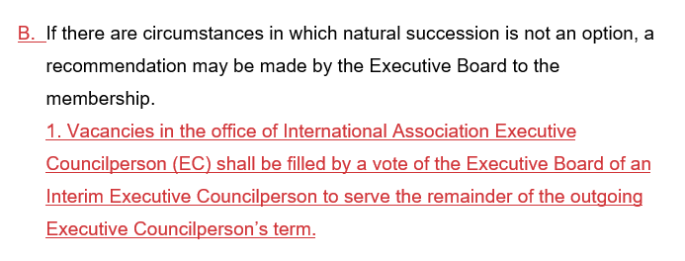

Article IV, Section 2, Paragraph F.
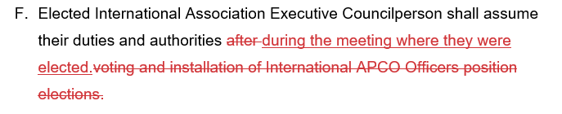
Article VII, Section 1, Paragraph A.

